Merna Ayad
MHA/599 – Capstone: Leading the Organization Through Change
Dr. Kathie Huttegger
Date: April 14, 2021

Introduction
Columbus is one of the most populous cities in the US. In 2019 its population was estimated at 898,553. The main ethnic groups in Columbus are Non-Hispanic (54.3%), black or African American (29%), Asian (6.13%), and White (3.28%). The average household economy in Columbus is $52,971 with males earning 1.34 times higher than females. Columbus has one of the best pediatric hospitals internationally, the best-ranked cancer hospital nationally and it has got two heart hospitals (Oza et al. 2011). The number of other medical centers has also been growing.
The current state of the health care system in Columbus
Columbus is ranked at number 47 in the value of health as compared to other cities. According to the Dashboard, the residents of Columbus live less healthy lives and spend a lot on health care than those in the other cities. The current leading causes of morbidity and mortality in Columbus include infectious diseases (seasonal influenza, sexually transmitted infections, reportable diseases, and Zika virus), injuries (overdose and addiction, youth suicide, injury hospitalization, and violence), and maternal and child health (infant mortality and child fatality review) (Franz et al.2018). Health Care and Social Assistance are one of the largest industries in Columbus employing 70,047 people. 172k out of the 843k people live below the poverty line. The most concentrated bachelor's degree in Columbus is nursing with 825 degrees awarded.
Health insurance is a health care system that is used for health service delivery in Columbus. 91.6% of the people in Columbus have health care coverage. There are 50.3% employee plans, 7.4% on Medicare, 23% on Medicaid, 1.21% on military or VA programs, 8.45% uninsured, and 9.64% on non-group programs (Oza et al. 2011). The individual health care spending in Columbus is $8,712 per capita. As compared to other counties, Columbus has the highest diabetes prevalence (19.1%). $4,371 is the personal health care spending by private health insurance, $7,007 is the Medicaid spending on individual health care while $11,038 is the Medicare spending on individual health. All personal health care spending including Medicaid, Private, and Medicare rose from $8,286 to $8,712, a 5.14% growth (Franz et al.2018). The percentage of uninsured people in Columbus decreased from 8.55% to 8.45% in 2017.
Proposed service
I would introduce the use of mobile clinics and medical teams to provide screening services for diseases such as cancer and other diseases as well as providing curative services to the vulnerable groups in the city of Columbus. This service will also include responding to childhood adversity and trauma which has not been effectively attended to. This will offer to ensure that the vulnerable and isolated groups get access to the services they need without straining. This service will involve health care providers using vehicles to visit different parts of the city to provide screening services and treat patients who are vulnerable and isolated.
This service will be important in reducing congestions in hospitals. This will in return reduce the number of people visiting hospitals hence reducing the waiting time. This will also help prevent or reduce the transmission of new diseases such as COVID-19. These clinics will serve the vulnerable groups in the community by providing high-quality care at lower costs. There will also be reduced childhood trauma and adversity. The mobile clinics will also improve access to health care services hence promoting the overall well-being of the city.
Designing health facility
The mobile clinic will use semi-trailers for designing the health facility. The length of these trailers ranges from 40’ to 60’, a width of 8’5” to 12’0” and a GVWR of 68,000 pounds. This will provide the greatest interior space-efficient for building the clinic. The semi-trailer will give 1,000 square feet of space. It will be divided into sections such as examination room, reception area and washroom. Proper and adequate ventilation will be maintained in the semi-trailer. The tractor to move the medical trailer will be removable and will only be rented when locating the medical trailer to a different location.
Floor plan
Different types of materials will be used for floor finishing depending on the various sections of the facility. This will ensure that the performance requirements for health care floors are met. For example, LVT, sheet, and linoleum will be used in examination rooms while the other rooms will use LVT, bio-based tile, and sheet tile for floor finishing.
Conclusion
The insurance health care system in Columbus includes providing the citizens with health care coverage such as Private insurance, Medicare, Medicaid, and military or VA programs. 91.6% of the people in Columbus have health care coverage while 8.45% are uninsured. Implementing the use of mobile clinics in the city may improve access, reduce hospital congestion and enhance the provision of quality and cost-effective services.
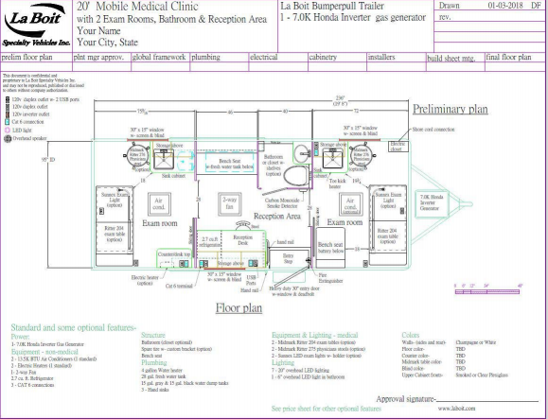

References
Oza-Frank, R., Norton, A., Scarpetti, H., Wapner, A., & Conrey, E. (2011). A report on the body mass index of Ohio’s third graders: 2009-2010. Columbus, OH: Ohio Department of Health.
Franz, B., Skinner, D., Kerr, A. M., Penfold, R., & Kelleher, K. (2018). Hospital–community partnerships: Facilitating communication for population health on Columbus’ South Side. Health communication, 33(12), 1462-1474.
https://www.columbus.gov/publichealth/About/Columbus-Public-Health-History

